2.Root Finding Algorithm

Root-finding algorithms are tools used in mathematics and computer science to locate the solutions, or "roots," of equations. These algorithms help us find solutions to equations where the function equals zero. For example, if we have an equation like f(x) = 0, a root-finding algorithm will help us determine the value of x that makes this equation true.
Different types of root finding algorithms are bisection method, Regula-Falsi method, Newton-Raphson method, and secant method. These algorithms are essential in various fields of science and engineering because they help solve equations that cannot be easily rearranged or solved analytically.
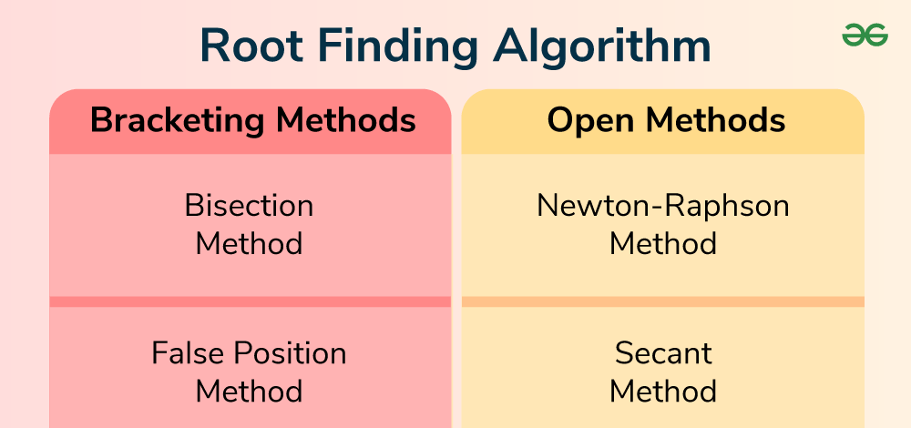

Types of Root Finding Algorithms

Root-finding algorithms can be broadly categorized into Bracketing Methods and Open Methods.

Bracketing Methods: This method starts with an interval where the function changes sign, ensuring that a root lies within this interval. These methods iteratively reduce the interval size to home in on the root.

- Bisection Method
- False Position (Regula-Falsi) Method

Open Methods: This starts with one or more initial guesses that do not necessarily bracket the root. These methods can converge more quickly but do not always guarantee convergence.
- Newton- Raphson Method
- Secant Method

Bracketing Methods

A bracketing method finds the root of a function by progressively narrowing down an interval that contains the root. It uses the intermediate value theorem, which states that if a continuous function changes signs over an interval, a root exists within that interval. Starting with such an interval, the method repeatedly reduces the interval size until it is small enough to identify the root.
For polynomials, additional techniques like Descartes' rule of signs, Budan's theorem, and Sturm's theorem can determine the number of roots in an interval, ensuring all real roots are found accurately.

The bracketing method is further classified into:

- Bisection Method
- False Position (RegulaFalsi) Method

Bisection Method
Bisection method is one of the simplest and most reliable root finding algorithms. It works by repeatedly narrowing down an interval that contains the root. We can use the bisection method using following methods:
Step 1: Start with two points, a and b, such that f(a) and f(b) have opposite signs. This guarantees that there is at least one root between a and b.
Step 2: Calculate the midpoint, c, of the interval [a,b] using c = (a + b)/2.
Step 3: Determine the sign of f(c). If f(c) is close enough to zero (within a predefined tolerance), c is the root. Otherwise, replace a or b with c depending on the sign of f(c), ensuring that the new interval still brackets the root.
Step 4: Repeat the process until the interval is sufficiently small or f(c) is close enough to zero.
Here, number of iterations needed to achieve an ε-approximate root using the bisection method is given by:
N≈log⁡2(b−aε))

False Position (RegulaFalsi) Method
False Position method, also known as the RegulaFalsi method, is a numerical technique used to find the roots of a function, where the function equals zero. It is similar to the bisection method but often converges faster. The False Position method combines the concepts of the bisection method and the secant method, making it both simple and efficient for solving equations.
Here’s a step-by-step explanation of how it works:
Step 1: Start with two points, a and b, such that f(a) and f(b) have opposite signs. This guarantees that there is at least one root between a and b.
Step 2: Calculate the midpoint, c, of the interval [a,b] using c = a - [f(a).(b - a)]/[f(b) - f(a)].
Step 3: Evaluate f(c). If f(c) is close enough to zero (within a predefined tolerance), then c is the root.
Step 4: Depending on the sign of f(c), update the interval:
- If f(a) and f(c) have opposite signs, set b = c.
- If f(b) and f(c) have opposite signs, set a = c.
Step 5: Repeat the process until the interval is sufficiently small or f(c) is close enough to zero.

Open Methods

Open methods are root-finding algorithms that don't necessarily require an interval containing the root. They start with one or more initial guesses and iteratively refine them until a root is found. These methods are generally faster but may not always converge.
In this section we will further learn about the classification of open method, that are:

- Newton- Raphson Method
- Secant Method

Newton-Raphson Method
Newton-Raphson method is an iterative algorithm that uses the derivative of the function to find the root. It’s faster than the bisection method but requires a good initial guess and the calculation of derivatives. Procedure is given as below:
Step 1: Start with an initial guess x0.
Step 2: Use the formula, xn+1=xn−f(xn)f′(xn​)​ to find the next approximation, where f'(xn) is the derivative of f(x) at xn.
Step 3: Repeat the iteration until the change between xn and xn+1​ is smaller than a predefined tolerance.
Note: Newton-Raphson method converges quickly when the initial guess is close to the root, but it can fail if f′(x) is zero or if the function is not well-behaved near the root.

Secant Method

Secant method is similar to the Newton-Raphson method but does not require the calculation of derivatives. Instead, it uses a secant line to approximate the root. Procedure of secant method is given as:
Step 1: Start with two initial guesses x0​ and x1​.
Step 2: Use the formula xn+1=xn−f(xn)xn−xn−1f(xn)−f(xn−1)xn+1​=xn​−f(xn​)f(xn​)−f(xn−1​)xn​−xn−1​​ to find the next approximation.
Step 3: Repeat the iteration until the change between xn and xn+1​ is smaller than a predefined tolerance.
Secant method can be faster than the bisection method and does not require the derivative of the function, but it can be less reliable than the Newton-Raphson method, especially if the initial points are not well chosen.

Comparison of Root Finding Methods

The comparison between the root finding methods are being showed below, on the basis of advantages and disadvantages.
Method | Description | Advantage | Disadvantage
Bisection Method | It divides interval in half, and guarantees convergence | Simple and faster method | Slow convergence
False Position Method | It uses linear interpolation, faster than bisection | It maintains bracketing, faster than bisection | It may fail due to roundoff errors
Newton's Method | It uses function and derivative, fast convergence | It is a quadratic convergence, works in higher dimensions | It may not converge if initial guess is far
Secant Method | It is a derivative-free variant of Newton's, simpler | It doesn't require derivative, faster than bisection | Slower convergence (order ~1.6)

Comparison of Root Finding Methods with Example

Solving the equation f(x)= x3−4x−9= 0 using Bisection Method, Regula-Falsi Method, Newton-Raphson Method, and Secant Method with 10 iterations. The computed root approximations are displayed in the table.
Method | Root Approximation
Bisection Method | 2.7060546875
Regula-Falsi Method | 2.7065276119801087
Newton-Raphson Method | 2.7065279765747587
Secant Method | 2.7065278974619447

Comparison of Methods:

- Bisection Method: Converged slowly, reaching 2.706055 after 10 iterations.
- Regula-Falsi Method: Improved on Bisection, reaching 2.706528 faster.
- Newton-Raphson Method: Fastest convergence, achieving 2.706528.
- Secant Method: Similar to Newton-Raphson, reaching 2.706528.

Observations:

- Newton-Raphson and Secant Methods provided the fastest and most accurate results.
- Bisection was the slowest, but it ensures convergence.
- Regula-Falsi performed better than Bisection but was slower than the derivative-based methods.

This comparison highlights that if derivatives are available, Newton-Raphson is preferred. If derivatives are difficult to compute, Secant Method is a good alternative.

How to Choose a Root Finding Algorithm?

Choosing a root finding algorithm depends on several factors:
- Function Properties: Consider whether the function is continuous, differentiable, and how well-behaved it is.
- Initial Knowledge: Determine if you have an initial interval containing the root or just a rough estimate.
- Accuracy Requirements: Assess how accurate the root approximation needs to be.
- Computational Resources: Consider the computational complexity and resources available.
- Robustness: Evaluate how robust the algorithm is against different function behaviors and initial guesses.
- Speed: Balance between convergence speed and computational efficiency.
- Dimensionality: For higher-dimensional problems, choose algorithms that extend well to multiple dimensions.

Applications of Root Finding Algorithms

The various applications of root-finding algorithms are:
- Numerical Analysis: It is important in numerical analysis for solving nonlinear equations, which commonly arise in mathematical modeling and simulation.
- Optimization: Form an integral part of optimization algorithms for minimizing or maximizing functions by finding their critical points.
- Finance: It is used in financial modeling and risk management for pricing options, forecasting, and analyzing financial derivatives.
- Image Processing: It is used in image processing algorithms, such as edge detection and image segmentation, for solving nonlinear equations.

Difference between Bisection Method and Newton Raphson Method

Numerical methods are the set of tasks by applying arithmetic operations to numerical equations. We can formulate mathematical problems to find the approximate result. This formulation is called the numerical implementation of the problem. In this, there is no need for algorithms. Programming logic is then developed for numerical implementation. The programming is usually done with some high-level languages like Fortran, Basic, etc.
In this article, we will discuss about Bisection Method and Newton Raphson Method as well as the differences between them.

The Bisection Method

The Bisection Method is a numerical technique used to find the root of a continuous function. It is one of the simplest and most reliable methods for solving equations of the form f(x)=0. The method works by repeatedly dividing an interval in half and then selecting the subinterval in which the function changes sign, indicating that a root lies within that subinterval.
Let f(x) is a continuous function in the closed interval [x1, x2], if f(x1), and f(x2) are of opposite signs, then there is at least one root α in the interval (x1, x2), such that f(α) = 0.

Formula for Bisection Method

Formula for Bisection Method is given as:
x2=(x0+x1)/2​
Where:
- x0 is the lower bound of the interval.
- x1 is the upper bound of the interval.
- x2 is the midpoint of the interval [x0, x1].

Newton Raphson Method

Newton-Raphson Method is a widely used iterative numerical technique for finding the roots of a real-valued function. It is particularly popular because of its fast convergence properties when the initial guess is close to the actual root.
It is the process for the determination of a real root of an equation f(x) = 0 given just one point close to the desired root.

Formula for Newton Raphson Method

Formula for Newton Raphson Method is given as:
xn+1=xn−f(xn)/f′(xn)​
Where:
- xn​ is the current approximation.
- xn+1​ is the next approximation.
- f(xn) is the value of the function at xn.
- f′(xn) is the value of the derivative of the function at xn​.

For first iteration, we can put n = 0 i.e.,
x1=x0−f(x0)/f′(x0​)​

Difference between Bisection Method and Newton Raphson Method
Some of the common key differences between bisection and Newton Raphson method are listed in the following table:
Parameter | Bisection Method | Newton Rapson Method
Rate of Convergence | Linear (slow) | Quadratic (fast)
Formula used | x2=x1+x02​​ | x1=x0−f(x0)f′(x0)​
Initial Approximations | Two initial guesses (x0 and x1) | One initial guess (x0)
Function Computations per Iteration | 1 | 2
Sensitivity to Initial Guess | Less sensitive | Very sensitive
Derivatives Needed | No | Yes
Applicability | Not suitable for complex, multiple, or closely spaced roots | Suitable for complex, multiple, or closely spaced roots

Bisection Method
The Intermediate Value Theorem says that if f(x) is a continuous function between a and b, and sign(f(a))≠sign(f(b)), then there must be a cc, such that a<c<b and f(c)=0. This is illustrated in the following figure.
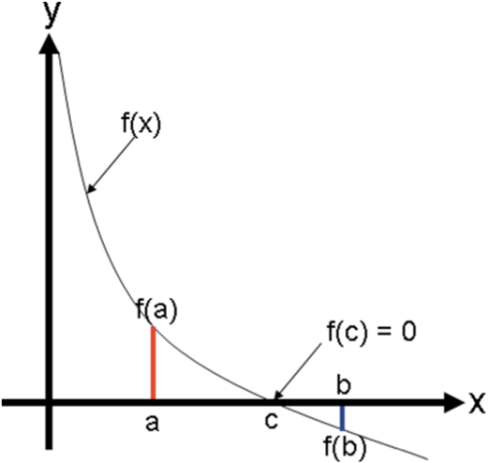

The bisection method uses the intermediate value theorem iteratively to find roots. Let f(x) be a continuous function, and a and b be real scalar values such that a<ba<b. Assume, without loss of generality, that f(a)>0 and f(b)<0. Then by the intermediate value theorem, there must be a root on the open interval (a,b)(a,b). Now let m=b+a2m=b+a2, the midpoint between and a and b. If f(m)=0 or is close enough, then mm is a root. If f(m)>0, then mm is an improvement on the left bound, aa, and there is guaranteed to be a root on the open interval (m,b)(m,b). If f(m)<0, then mm is an improvement on the right bound, b, and there is guaranteed to be a root on the open interval (a,m). This scenario is depicted in the following figure.
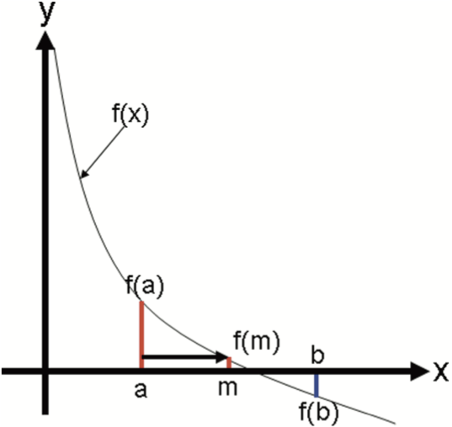

The process of updating a and b can be repeated until the error is acceptably low.

Program a function my_bisection(f, a, b, tol) that approximates a root r of f, bounded by a and b to within |f(a+b2)|<tol.
Import numpy as np

def my_bisection(f,a,b,tol):
# approximates a root, R, of f bounded
# by a and b to within tolerance
# | f(m) | <tol with m the midpoint
# between a and b Recursive implementation

# check if a and b bound a root
If np.sign(f(a))==np.sign(f(b)):
Raise Exception(
"The scalars a and b do not bound a root")

# get midpoint
m=(a+b)/2

if np.abs(f(m))<tol:
# stopping condition, report m as root
Return m
Elif np.sign(f(a))==np.sign(f(m)):
# case where m is an improvement on a.
# Make recursive call with a = m
Return my_bisection(f,m,b,tol)

Elif np.sign(f(b))==np.sign(f(m)):
# case where m is an improvement on b.
# Make recursive call with b = m
Return my_bisection(f,a,m,tol)

The 2–√2 can be computed as the root of the function f(x)=x²−2.
Starting at a=0and b=2, use my_bisection to approximate
the 2–√2 to a tolerance of |f(x)|<0.1 and |f(x)|<0.01.
Verify that the results are close to a root by plugging the root back into the function.
f=lambda x:x**2-2

r1=my_bisection(f,0,2,0.1)
print("r1 =",r1)
r01=my_bisection(f,0,2,0.01)
print("r01 =",r01)

print("f(r1) =",f(r1))
print("f(r01) =",f(r01))

r1 = 1.4375
r01 = 1.4140625
f(r1) = 0.06640625
f(r01) = -0.00042724609375

See what will happen if you use a=2 and b=4 for the above function.
my_bisection(f,2,4,0.01)

---------------------------------------------------------------------------
ExceptionTraceback (most recent call last)
<ipython-input-3-4158b7a9ae67>in<module>
---->1my_bisection(f,2,4,0.01)

<ipython-input-1-36f06123e87c> in my_bisection(f, a, b, tol)
if np.sign(f(a))==np.sign(f(b)):
raise Exception(
"The scalars a and b do not bound a root")

# get midpoint

Exception: The scalars a and b do not bound a root

Newton-Raphson Method
Let f(x) be a smooth and continuous function and xr be an unknown root of f(x). Now assume that x0 is a guess for xr. Unless x0 is a very lucky guess, f(x0) will not be a root. Given this scenario, we want to find an x1 that is an improvement on x0 (i.e., closer to xr than x0). If we assume that x0 is “close enough” to xr, then we can improve upon it by taking the linear approximation of f(x) around x0, which is a line, and finding the intersection of this line with the x-axis. Written out, the linear approximation of f(x) around x0 is f(x)≈f(x0)+f′(x0)(x−x0). Using this approximation, we find x1 such that f(x1)=0
. Plugging these values into the linear approximation results in the equation
f(x0)+f′(x0)=(x1−x0),
which when solved for x1 is x1=x0−f(x0)/f′(x0).
An illustration of how this linear approximation improves an initial guess is shown in the following figure.
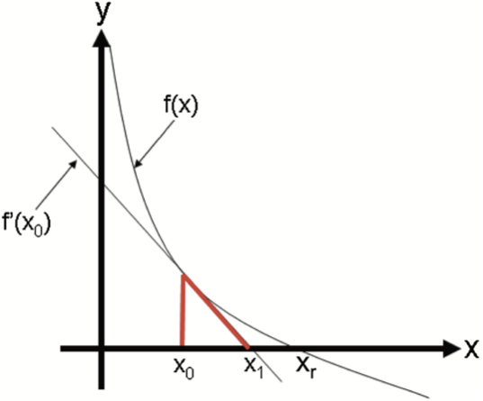
Written generally, a Newton step computes an improved guess, xi, using a previous guess xi−1, and is given by the equation
xi=xi−1−g(xi−1)/g′(xi−1).
The Newton-Raphson Method of finding roots iterates Newton steps from x0 until the error is less than the tolerance.
Again, the 2–√2 is the root of the function f(x)=x²−2. Using x0=1.4 as a starting point, use the previous equation to estimate 2–√2. Compare this approximation with the value computed by Python’s sqrt function.
x=1.4−1.42−22(1.4)=1.4142857142857144
import numpy as np

f=lambda x:x**2-2
f_prime=lambda x:2*x
newton_raphson=1.4-(f(1.4))/(f_prime(1.4))

print("newton_raphson =",newton_raphson)
print("sqrt(2) =",np.sqrt(2))
output:
newton_raphson = 1.4142857142857144
sqrt(2) = 1.4142135623730951

Write a function my_newton(f,df,x0,tol)my_newton(f,df,x0,tol), where the output is an estimation of the root of f, f is a function object f(x), df is a function object to f′(x), x0 is an initial guess, and tol is the error tolerance. The error measurement should be |f(x)|.
Def my_newton(f,df,x0,tol):
# output is an estimation of the root of f
# using the Newton Raphson method
# recursive implementation
If abs(f(x0))<tol:
return x0
else:
return my_newton(f,df,x0-f(x0)/df(x0),tol)

Use my_newton= to compute 2–√2 to within
tolerance of 1e-6 starting at x0 = 1.5.
#Driver code
f=lambda x:x**2-2
f_prime=lambdax:2*x
estimate=my_newton(f,f_prime,1.5,1e-6)
print("estimate =",estimate)
print("sqrt(2) =",np.sqrt(2))
output:
estimate = 1.4142135623746899
sqrt(2) = 1.4142135623730951

If x0 is close to xr, then it can be proven that, in general, the Newton-Raphson method converges to xr much faster than the bisection method. However since xr is initially unknown, there is no way to know if the initial guess is close enough to the root to get this behavior unless some special information about the function is known a priori (e.g., the function has a root close to x=0. In addition to this initialization problem, the Newton-Raphson method has other serious limitations. For example, if the derivative at a guess is close to 0, then the Newton step will be very large and probably lead far away from the root. Also, depending on the behavior of the function derivative between x0 and xr, the Newton-Raphson method may converge to a different root than xr that may not be useful for our engineering application.
Compute a single Newton step to get an improved
approximation of the root of the function
f(x)=x³+3x²−2x−5 and an initial guess, x₀=0.29.
x₀=0.29
x₁=x₀-(x0**3+3*x0**2-2*x0-5)/(3*x0**2+6*x0-2)
print("x1 =",x1)

x1 = -688.4516883116648

Note that f′(x0)=−0.0077 (close to 0) and the error at x1 is approximately 324880000 (very large).
Consider the polynomial f(x)=x³−100
X²−x+100.
This polynomial has a root at x=1 and x=100. Use the Newton-Raphson to find a root of ff starting at x0=0.
At x0=0,f(x0)=100x0=0,f(x0)=100, and f′(x)=−1f′(x)=−1. A Newton step gives x1=0−100−1=100x1=0−100−1=100, which is a root of ff. However, note that this root is much farther from the initial guess than the other root at x=1, and it may not be the root you wanted from an initial guess of 0.

